Bug Report-Cushon

During the automation test execution, I covered functional tests of UI, cross browser testing and Api testing.
- UI: Executed Login and BasketCheckout features and identified bugs.
- API Testing: I have automated multiple scenarios using Reqnroll, RestSharp, and the C# framework, found a bug in one of the API scenarios.
- All the bugs found during this testing phase are listed below.

UI Test Bugs:-
- Bug title: Login Success with Invalid username and password
Description:
When a user tries to log in with a correct username but an incorrect password, they are still able to log in successfully. This should not happen. The system should show an error message and not allow the login if the password is wrong. This is a security problem because it lets people log in without the correct password.
Steps to Reproduce:
@Scenario_01
Scenario Outline: User attempts to log in with different credentials
Given the user is on the sweet shop home page
Then the user should be able to see the title 'Welcome to the sweet shop!'
When user clicks login button on navigation bar
When the user enters the username '<Username>'
And the user enters the password '<Password>'
And clicks the login button
Then the user should see '<Message>'
Examples:
| Username | Password | Message |
| Invalid UserName | Invalid Password | Please enter a valid email address. |
Expected Result:
An error message should appear, saying that “Please enter a valid user name.”, and “Please enter a valid user name.”, and the user should not be logged in.
Actual Result:
The user is logged in successfully despite entering the wrong password.

Attachments:
- Screenshot showing successful login with incorrect username and password.
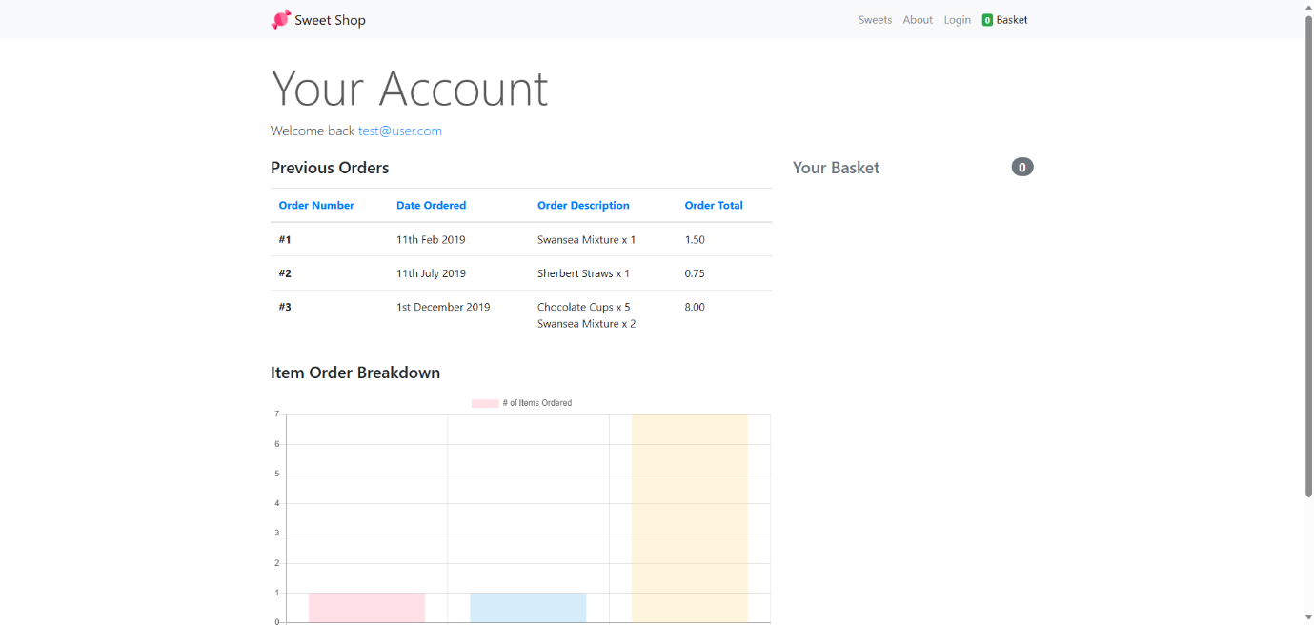

- Bug title: Checkout functionality doesn’t work and clears all fields without any error message

Description:
When the user clicks the "Continue Checkout" button, nothing happens, and all the information is cleared. There’s no error message to explain what went wrong it might lead confusion to end user.

Steps to Reproduce:
@Scenario_01
Scenario: Checkout functionality
Given the user is on the sweet shop home page
Then the user should be able to see the title 'Welcome to the sweet shop!'
When the user clicks the 'Add to Basket' button for a sweet 'Chocolate Cups'
Then the user should be able to see the basket 1
When the user navigates to the 'Basket'
Then the user should be able to see the valid 'Your Basket'
Then the user should be albe to see the your basket is 1
When the user enters details to billing adress
| Field | Value |
| First name | ABCDEF |
| Last name | GHIJK |
| Email | test@example.com |
| Address | 1234 Main st |
| Zip | 1234 |
When the user selects an option from the below dripdowns
| Dropdown | Value |
| Country | United Kingdom |
| City | Bristol |
When the user enters details to Payment
| Field | Value |
| Name on card | ABED |
| Credit card number | 123123 |
| Expiration | 1226 |
| CVV | 213 |
When the user click on the 'Continue to checkout' button
Then the user should be albe to see the your basket is 0

Expected Result:
Clicking "Continue Checkout" should take the user to the next step or show an error message if something goes wrong.
Actual Result:
Clicking "Continue Checkout" does nothing, and all the fields are cleared with no error message.
Attachments:
- Screenshot showing successful login with incorrect username and password.
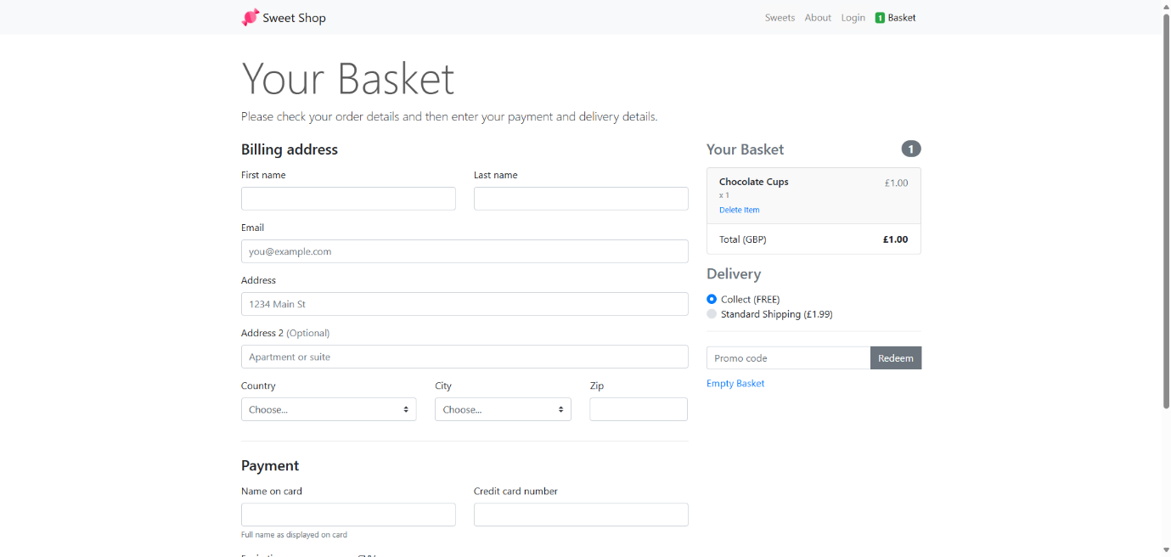

API Test Bugs:
Bug Title: API Endpoint Accessible with invalid token
Description:
The API endpoint is returning a response even when invalid bearer token is provided. This should not happen, as the API should require a valid token for access.
Steps to Reproduce:
@scenario_01 @api
Scenario: Valid and invalid authentication token
Given the user have a valid token
When the user makes a Get request to '/airports'
Then the response status should be 200
When the user send a Get request to '/airports' with an invalid token '1234567'
Then the response status should be 401
And the response body should contain an error message 'Unauthorized'
Expected Result:
The API should return an error (401 Unauthorized) when no bearer token is provided.
Actual Result:
The API responds successfully without requiring a bearer token.
Note:- As this scenario has been run using restsharp the screenshot won’t be available but for better understanding I have run the same using the postman. Please find attached the screenshot below.

